Maharaja Surajmal Institute



Assignment of “C Programming”

Name: Varun

Course: BCA

Batch: 2023-2026

Submitted to: Neetu Narwal

Q1. **Program 1**: WAP

to calculate the real root of the equation ax2+bx+c=0

using the quadratic formula



Test with a=1, b=-7 , c=12, roots are 3 and 4

Output:

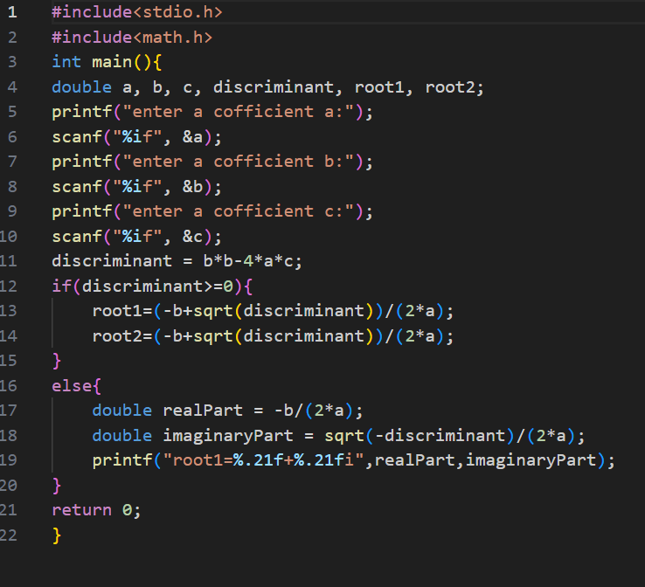



**Program 2**: WAP to calculate Compound interest using formula

Consider n as 1 in this example



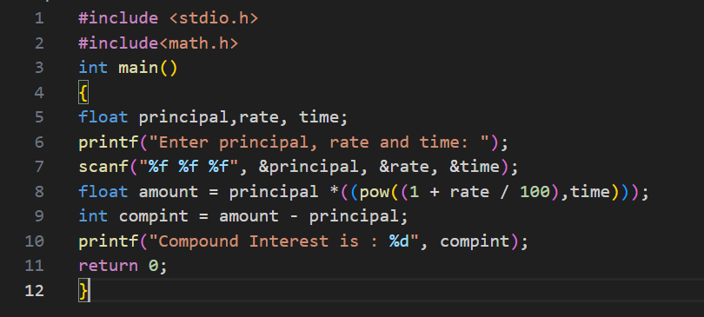

Output:



**Program 3:** : WAP to calculate degrees Celsius given temperature in degrees Fahrenheit using the formula

C= (5/9) * (F-32)

Test with following values 68,150,0,-22(degrees Fahrenheit 154.4, 302,32,-7.6).

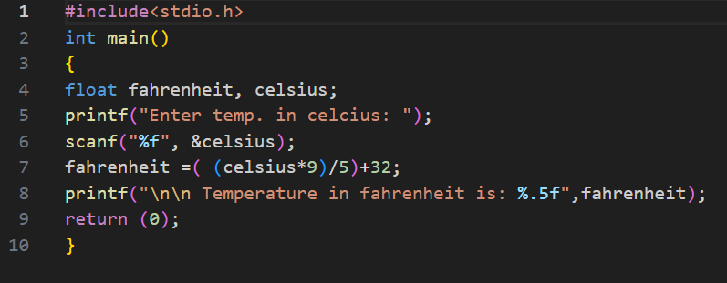output:

**Program 4:** WAP to Calculate the volume and area of a sphere using the formulas accept radius from user

 

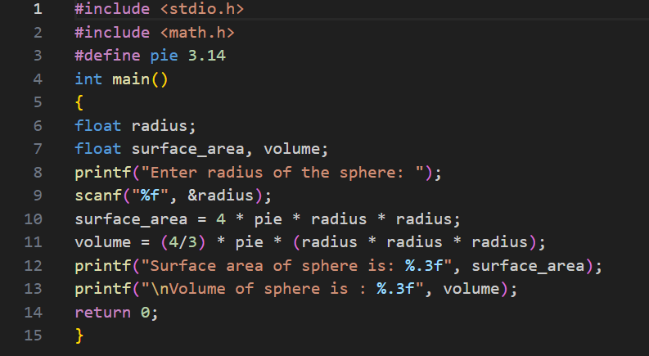Test with radius=9cm, Volume = 3053.628 cm3 , Area= 1017.87 cm

Output:



**Program 5**: WAP to accept a character from user and check whether an alphabet is vowel or consonant using conditional operator

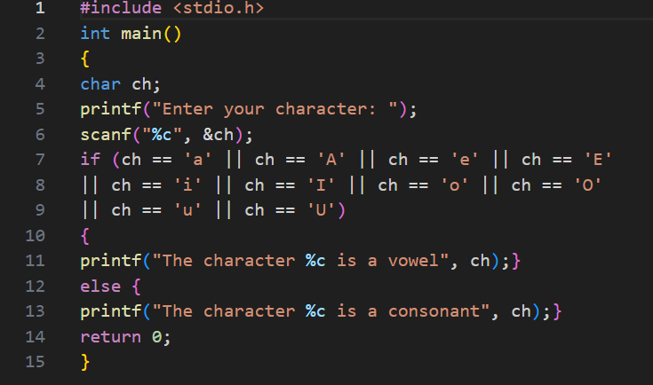output:



**Program 6**: Write a Program to calculate diameter, circumference and area of circle accept radius from user

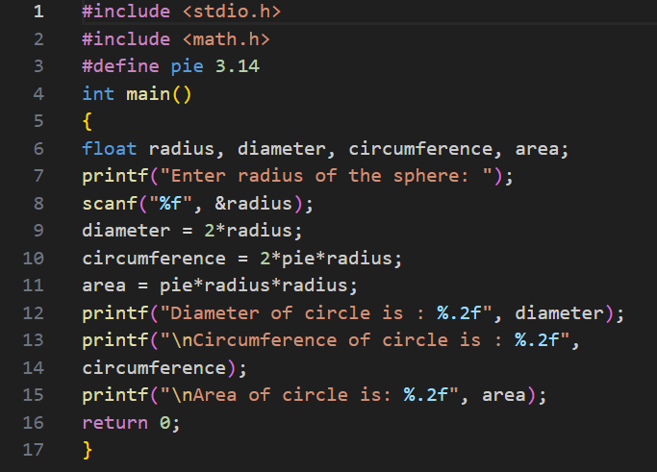

Output:



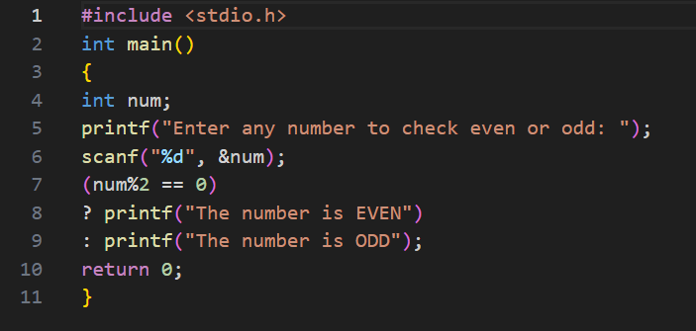**Program 7:** WAP to accept number from user and display whether it is even or odd. Hint : use conditional and modulus operator

Output:

**Program 8:** WAP to accept a character and display whether it is Capital Letter, Small Letter or Integer value

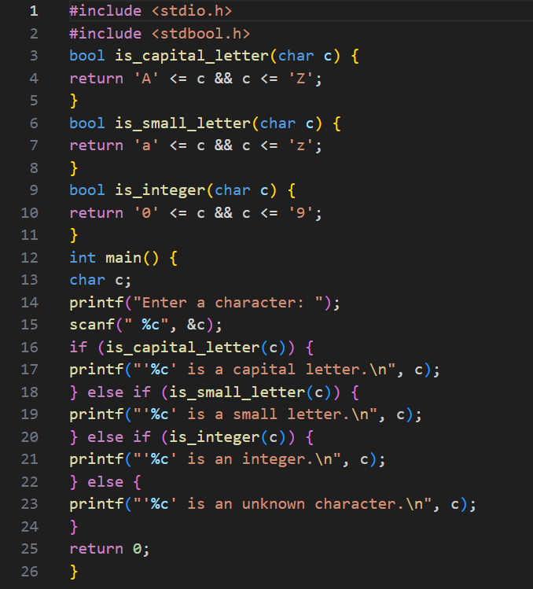

Output:



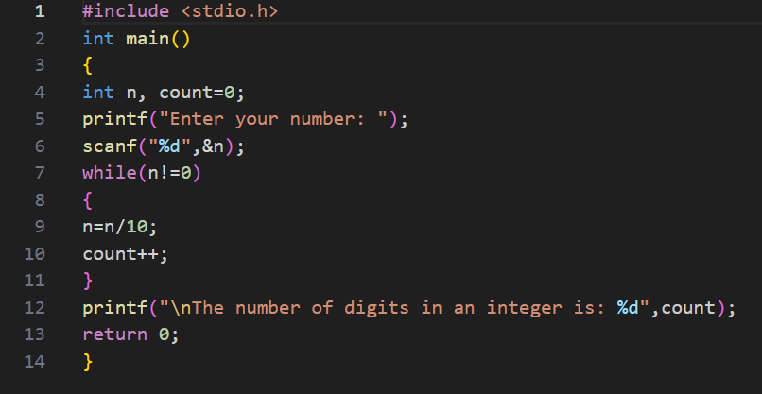**Program 9:** Write a program to count number of digits in any number

Output:



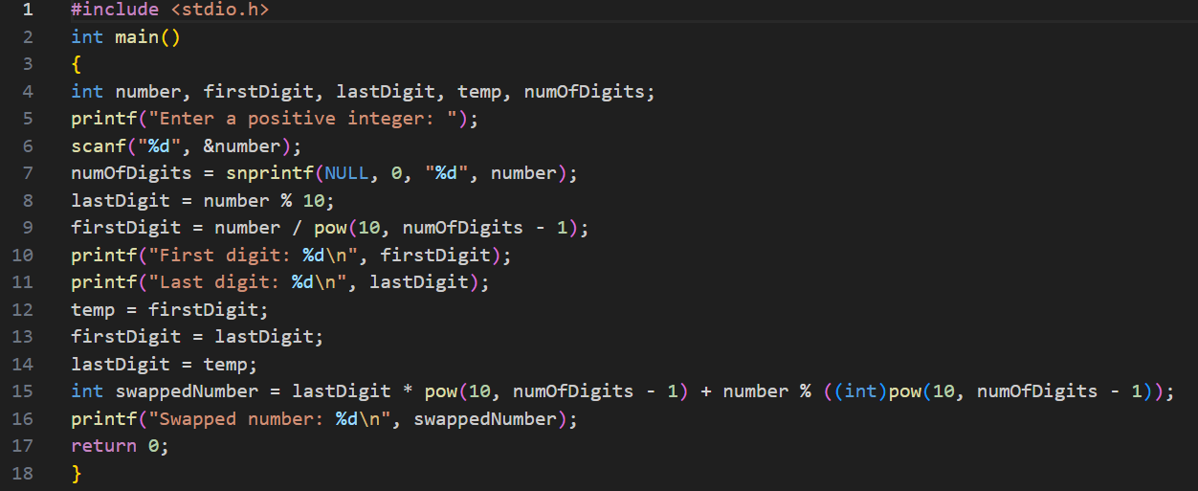**Program 10:** Write a program to find first and last digit of any number and display them, then swap the digits and create a new number and display it

Output:



**Program 11:** Write a program to enter any number and print all factors of the number

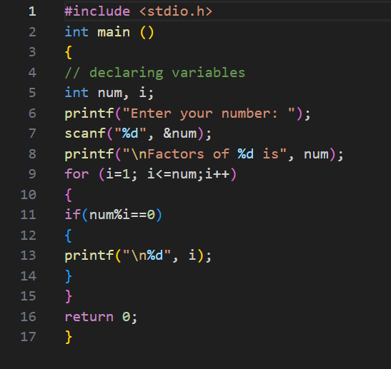

Output:



**Program 12:** Write a Program to enter any number and calculate its factorial

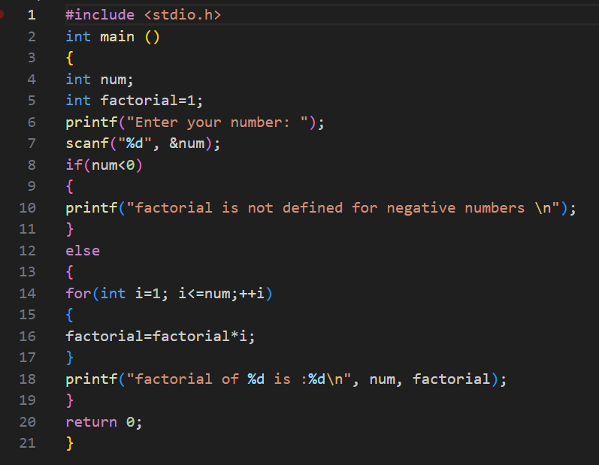

Output:



**Program 13:** Write a program to find HCF (GCD) of two numbers

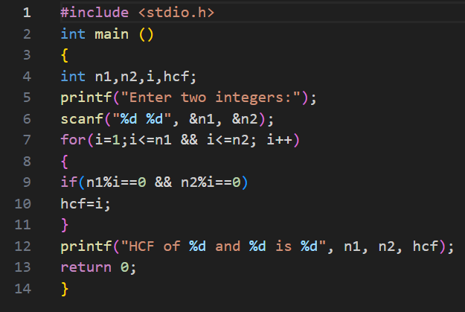

Output:

**Program 14:** Write a Program to find LCM of two numbers

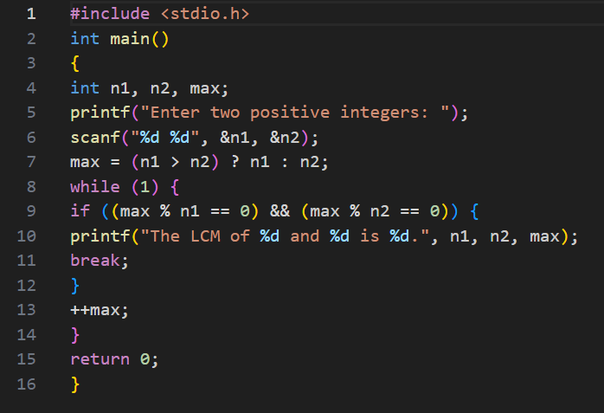

Output:



**Program 15:** Write a program to check whether a number is Prime number or not

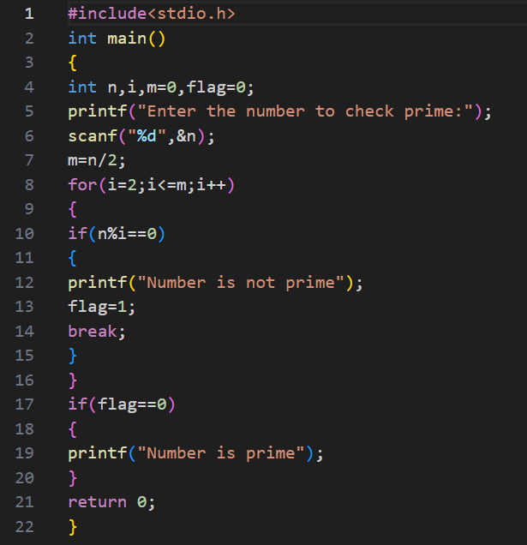

Output:



**Program 16:** Write a program to find sum of all prime numbers between 1 to n

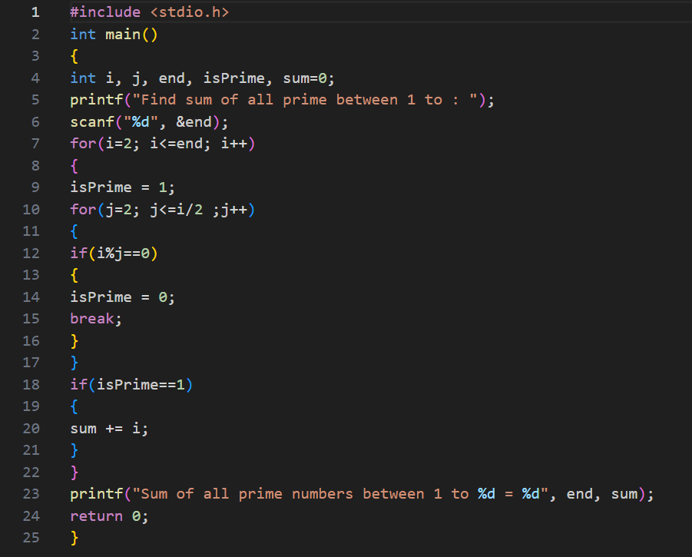

Output:



**Program 17:** Write a function “power (a,b)”, to calculate the value of a raised to the power of b

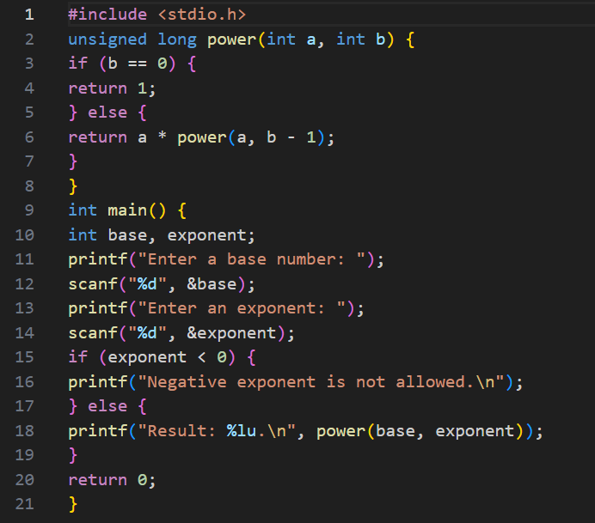

Output:



**Program 18:** Write a program to enter any number and print all factors of the number

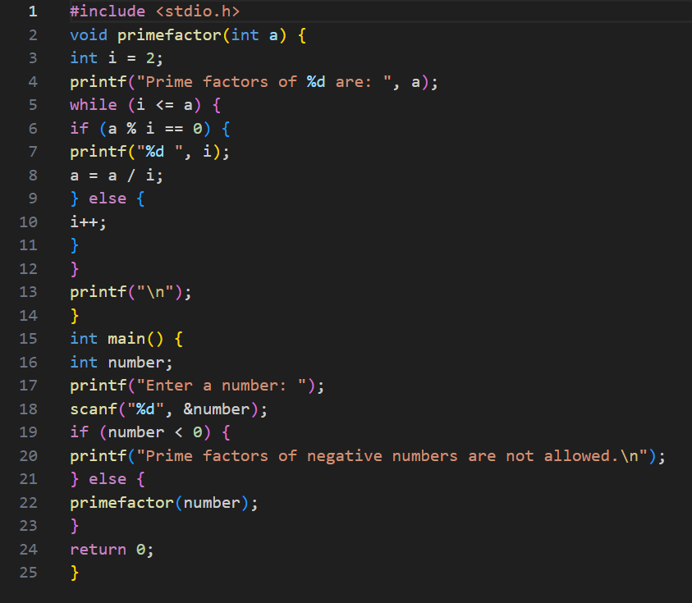

Output:



**Program 19:** Write a C program with function name Compound Interest (P ,r ,t) it receives 3 arguments principal, rate, time and displays the sum, average and the standard deviation of these numbers

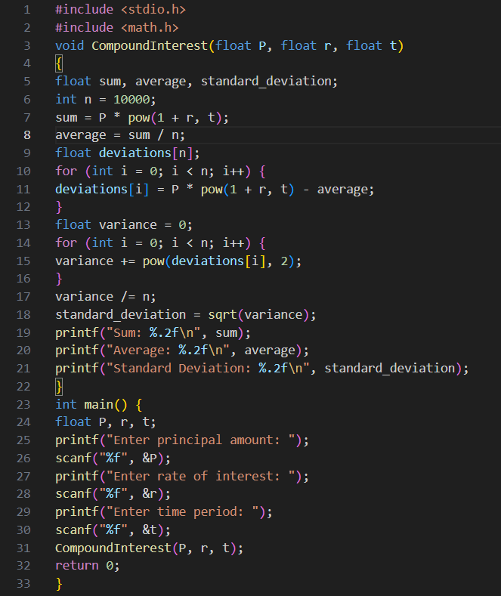

Output:



**Program 20:** Write a function Palindrome(a), that accepts an integer and return 1 if the number is a palindrome number and return 0 if it is not

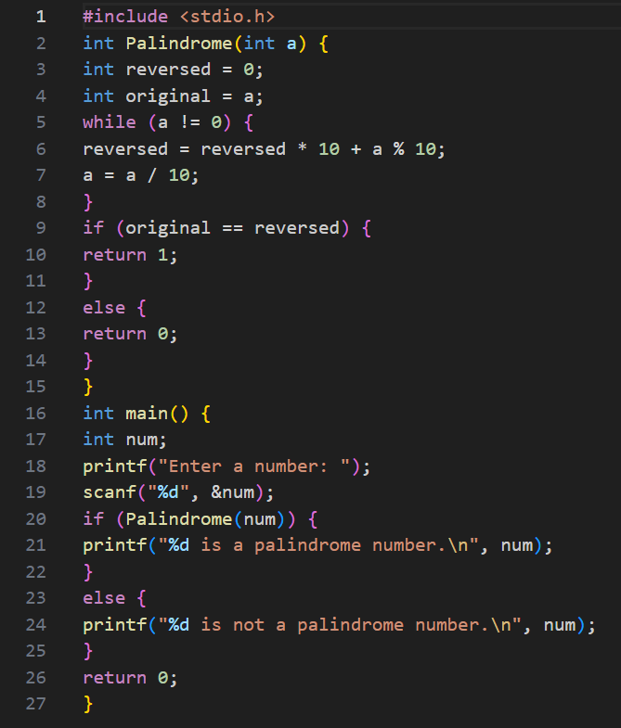

Output:



**Program 21:** Write a recursive function GCD Rec (a ,b), that accepts two integer values and returns the GCD of two numbers.

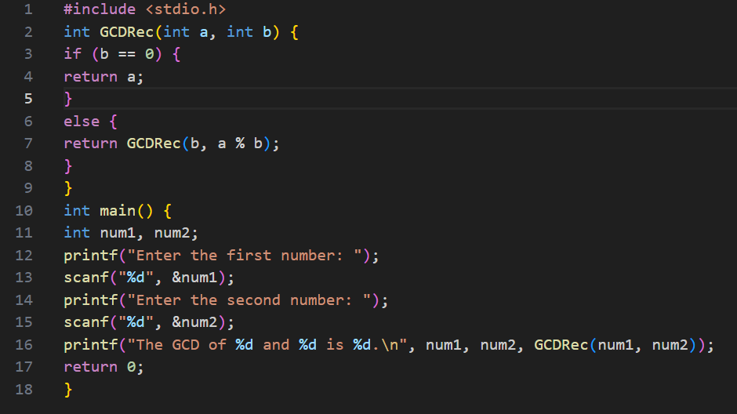

Output:



**Program 22:**  Write a recursive function Fibo Rec(a), that accepts number of terms to be displayed in fibonacci series starting with 1 ,1

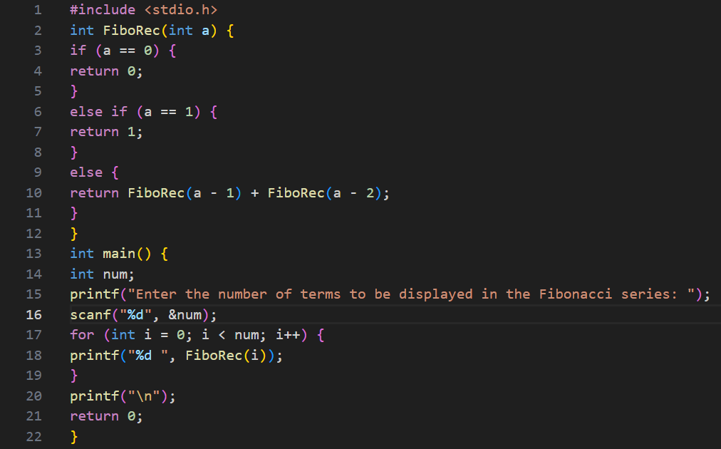

Output:



**Program 23:** Write a recursive fuction SumTermRec(a), that accepts an integer value and return the sum of all the digits.

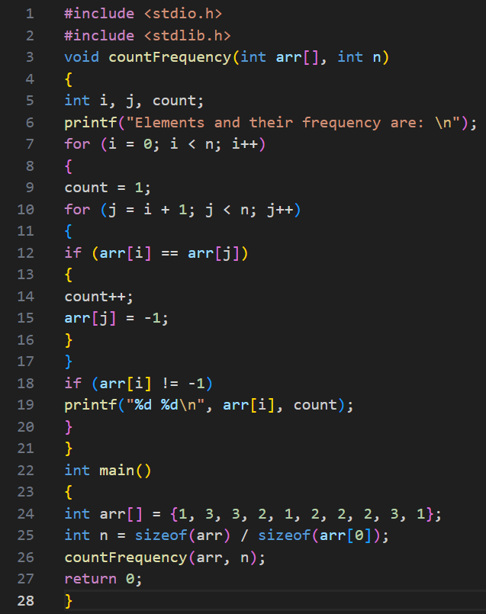

Output:



**Program 24:** Write a recursive function DectoBinaryRec(a), that accepts an integer and return Binary equivalent of the decimal number.

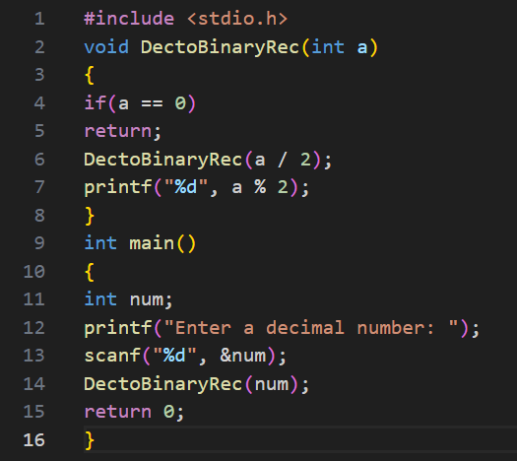

Output:



**Program 25:** Write a Program to count frequency of each element in an array

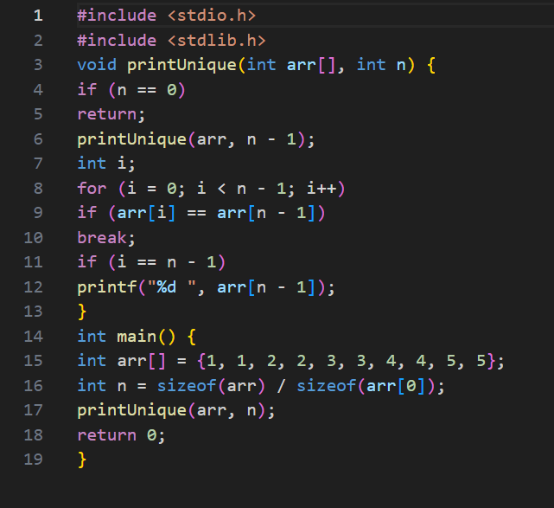

Output:



**Program 27:** Write a Program to find reverse of an array

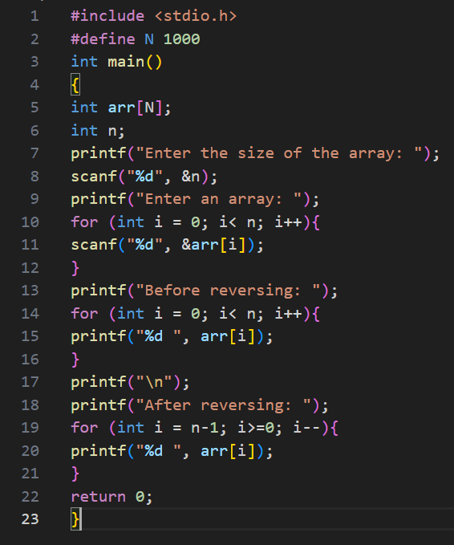

Output:



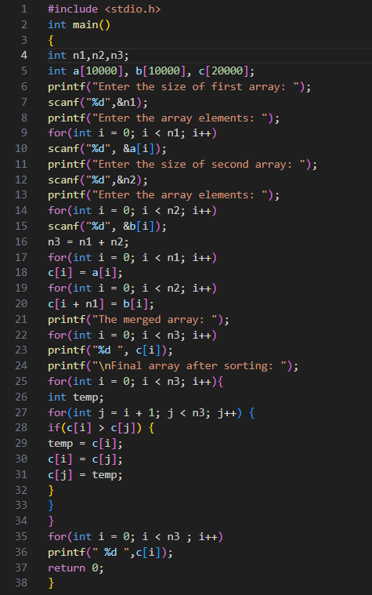**Program 28:** Write a Program to merge two arrays to third array

Output:



**Program 29:** Write a program to accept 5 elements, performs sorting operation with two functions : SelectionSortAsc(), SelectionSortDesc()

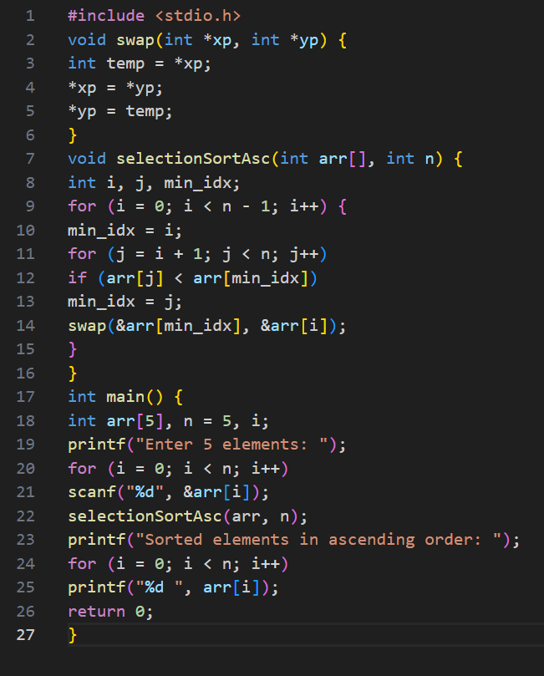

Output:



**Program30:** Write a Program to delete a specific element specified by the user and then shift all the elements towards left and last element will become zero.

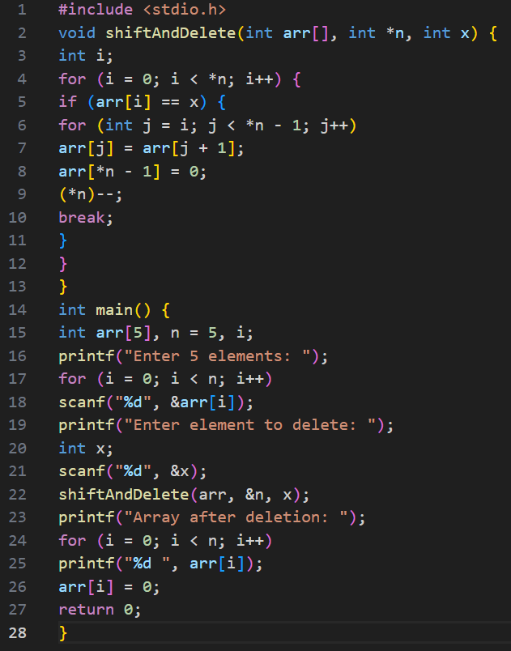

Output:

